# **“PROJECT DELIVERABLE 1”**

# **Project:**

**“Dinosaur Game“**

Names:

**M.Fiaz**

**M.Hammad Maqsood**

Roll #’s:

**L17-4331**

**L17-4417**

Section:

**CS-B**

Date:

**14 November 2018**

Delivered to:

P**rof. Bismillah Jan**

Table of Contents:

UML class diagram 3

WORKING 4

WORKING 5

* **UML CLASS DIAGRAM:**

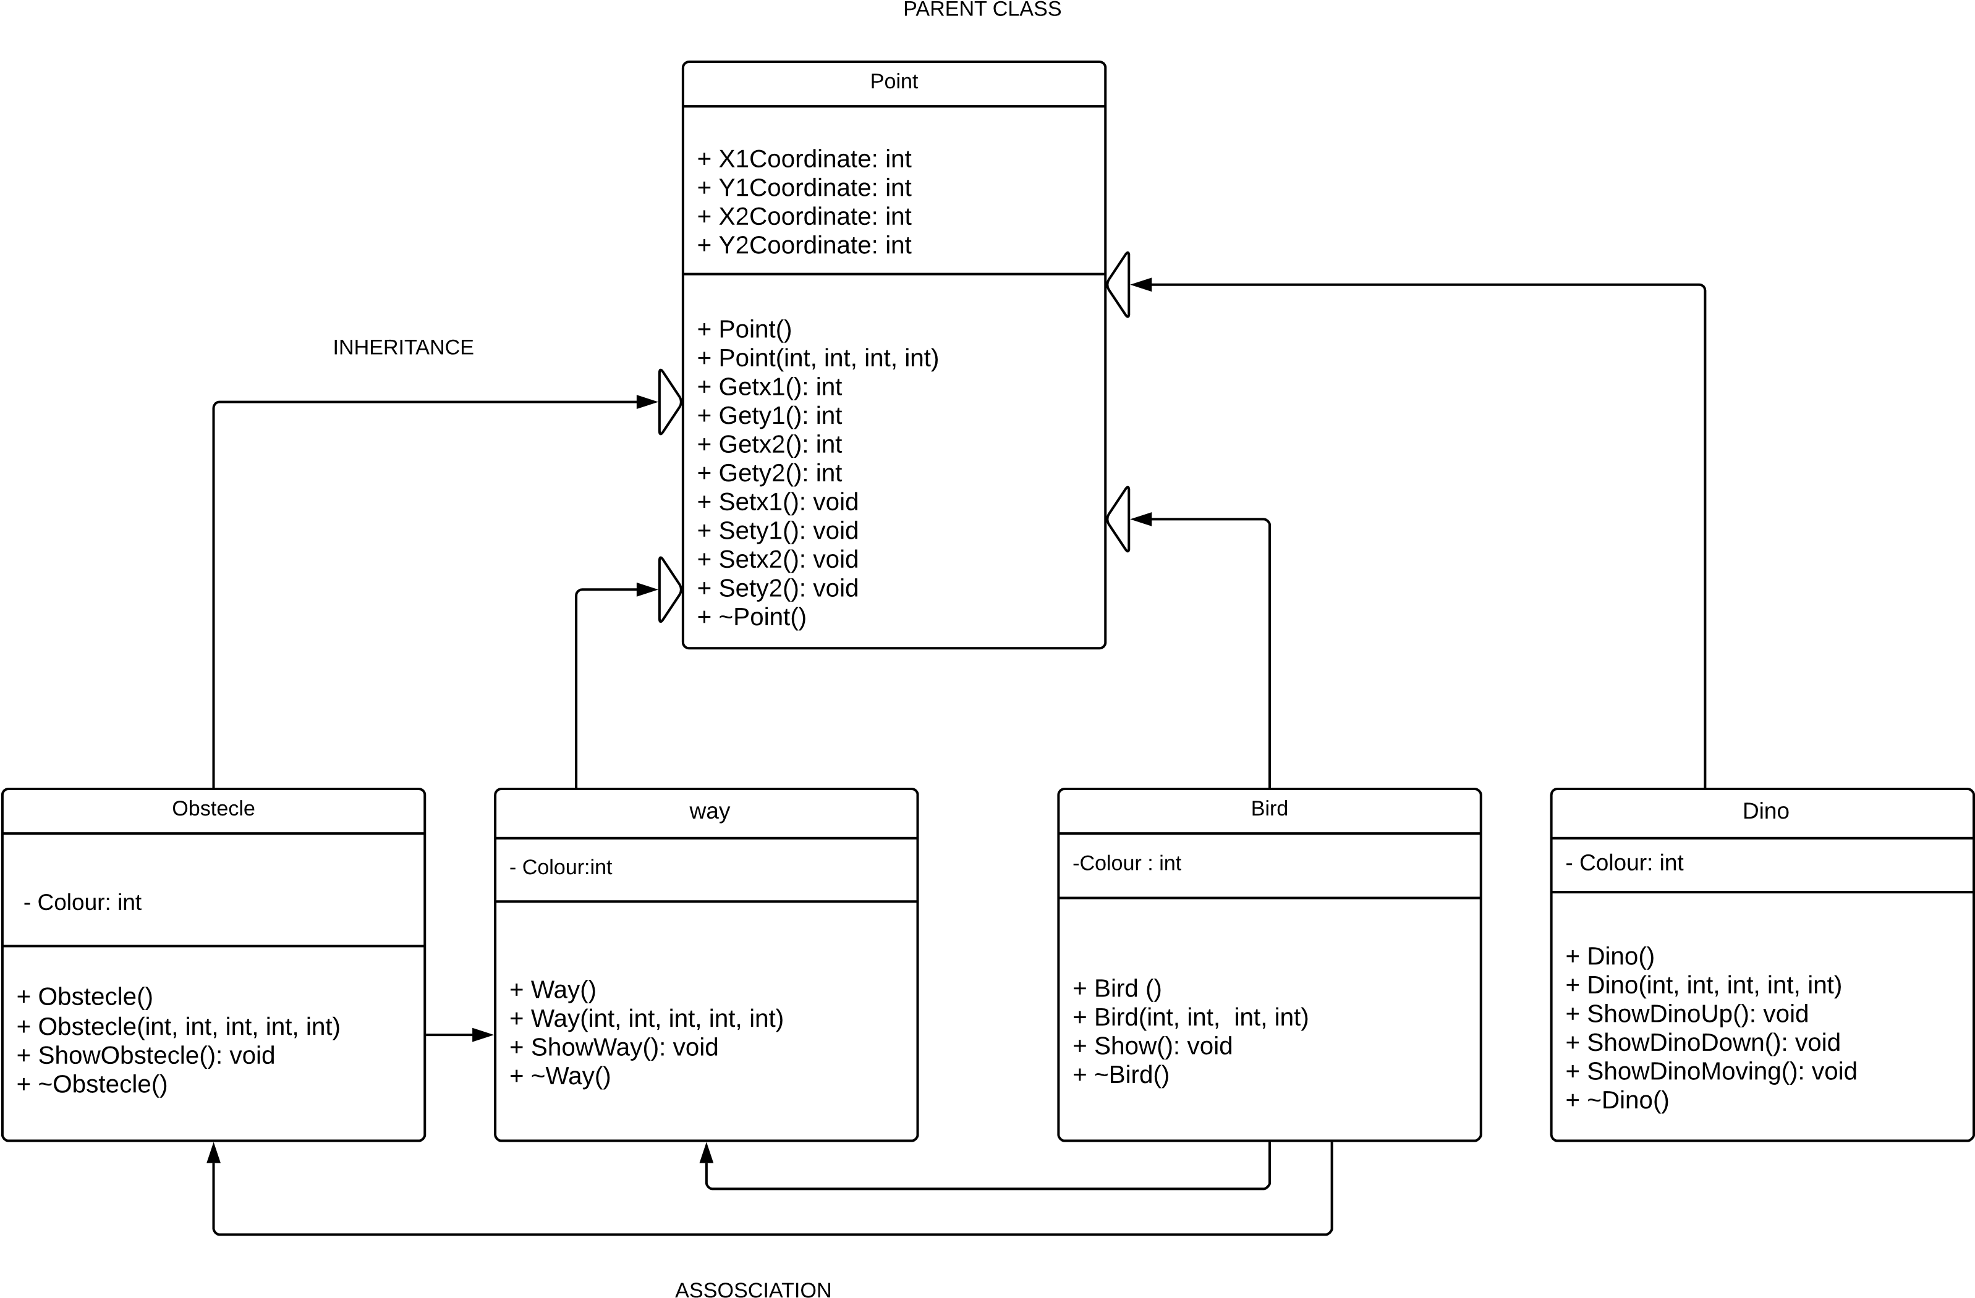

**WORKING:**

Basically, we will implement the project of game “**DINASOUR”** by using graphics files. In this we make five classes. **POINT** class is our parent class and remaining four are our **CHILD** classes which include class **DINO, OBSTECLE, WAY** and **BIRD.**  We make separate class for every object and implement its function in relevant class. Here is the brief explanation of classes we used.

* **CLASS DINO:**

In this class basically we give the coordinate for showing the dinosaur shape and implement two or three functions relevant to shape of dinosaur when he jump when he lay down and many other and further we use **_getch()** command to input a character from keyboard like space for jump and _**kbhit()**  to check which key is pressed. For this purpose, we use **stdio.h Library.** And actually we inherit our class dinosaur to point class.

* **CLASS WAY:**

In this class basically again we input points or coordinates to draw the way of dinosaur and the randomly generate **obstacle’s** and **birds** at a suitable distance. For this purpose, we use graphic library.

* **CLASS BIRD:**

In this class basically, we input the coordinates to build the shape of bird which appears after the **score reaches 200**. In this we specially use **random** which is built in c++ library. We associate the class bird with class way and class dinosaur to so that it can print at suitable distance from dinosaur and way of the dinosaur.

* **CLASS OBSTECLE:**

In this class basically we built the obstacle of suitable shape with the help of graphics library and generate it randomly at the end of screen. In this we **srand () or rand () to** generate it randomly on the screen which moves towards the dinosaur. Class **point** is our parent class and class **obstacle** is our child class. We inherited it from class **point.** We also make a function of collision when coordinates of the dinosaur collides with coordinates of obstacle the game stops and the total scores appears.

* **CLASS POINT:**

This class is our **parent class** and all other classes are inherited through it. Basically in this class we input the coordinates or points or axis which can help the other classes to set its coordinates accordingly. This is the main class of our project which will be very helpful to us.

* **STATIC AND GLOBAL VARIABLES AND FUNCTIONS:**

Basically, we will make it if we want one or two static variables of name **score** and **count.**  By using this, we maintain the score and in each class we check it whether it exceed the value of 200 or not to generate the bird after such instance.

* **NOTE:**

In this project deliverable, we make the sketch of our whole project in simple and easy word. However, **we can change it little bit** when we implement the project on visual studio according to our ease and the requirement. We can add more functions more variables to make program better and easy to understand.